13.78: a) 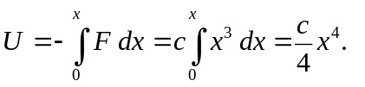

- From conservation of energy, 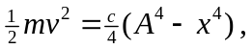and using the technique of Problem 13.77, the separated equation is
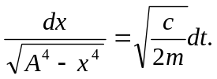

Integrating from 0 to  with respect to and from 0 to 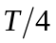 with respect to

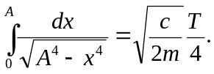

To use the hint, let 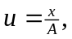 so that 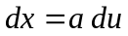 and the upper limit of the integral is 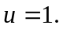 Factoring 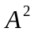 out of the square root,

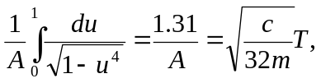

which may be expressed as 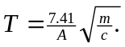 c) The period does depend on amplitude, and the motion is not simple harmonic.

